**Week 2**

* Install Android Studio
* Install Arduino IDE

<https://downloads.arduino.cc/arduino-1.8.9-windows.exe>

* Open Arduino IDE and follow the instructions in the link below. Follow only until the part where you have installed the additional boards.

<https://randomnerdtutorials.com/how-to-install-esp8266-board-arduino-ide/>

* Once you have added ESP8266 Boards on the board list of Arduino, change your board to LOLIN(WEMOS) D1 R2 & mini

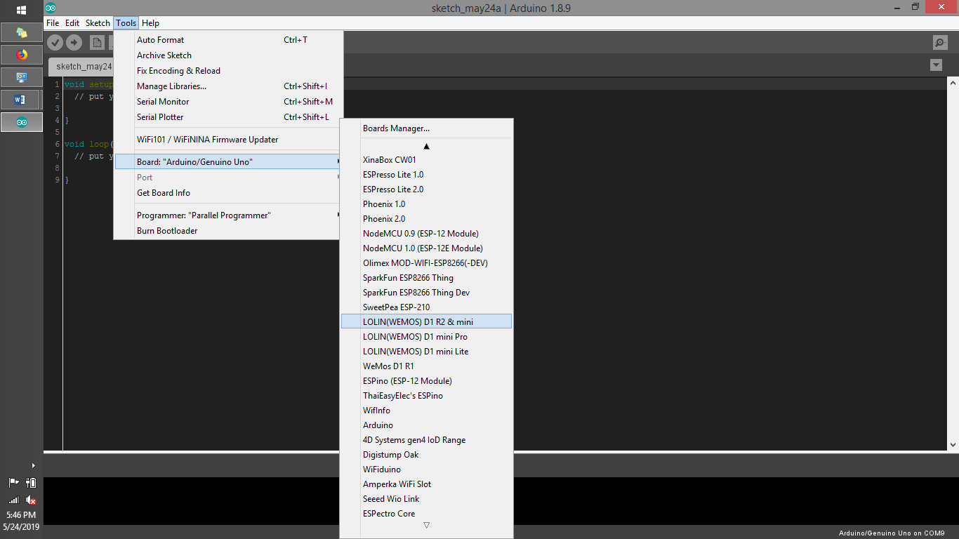

* Now, test if you can upload a code to your WeMos.
* Connect the USB cable to the WeMos D1 mini and your computer.
* Then go to File->Examples-ESP8266-Blink

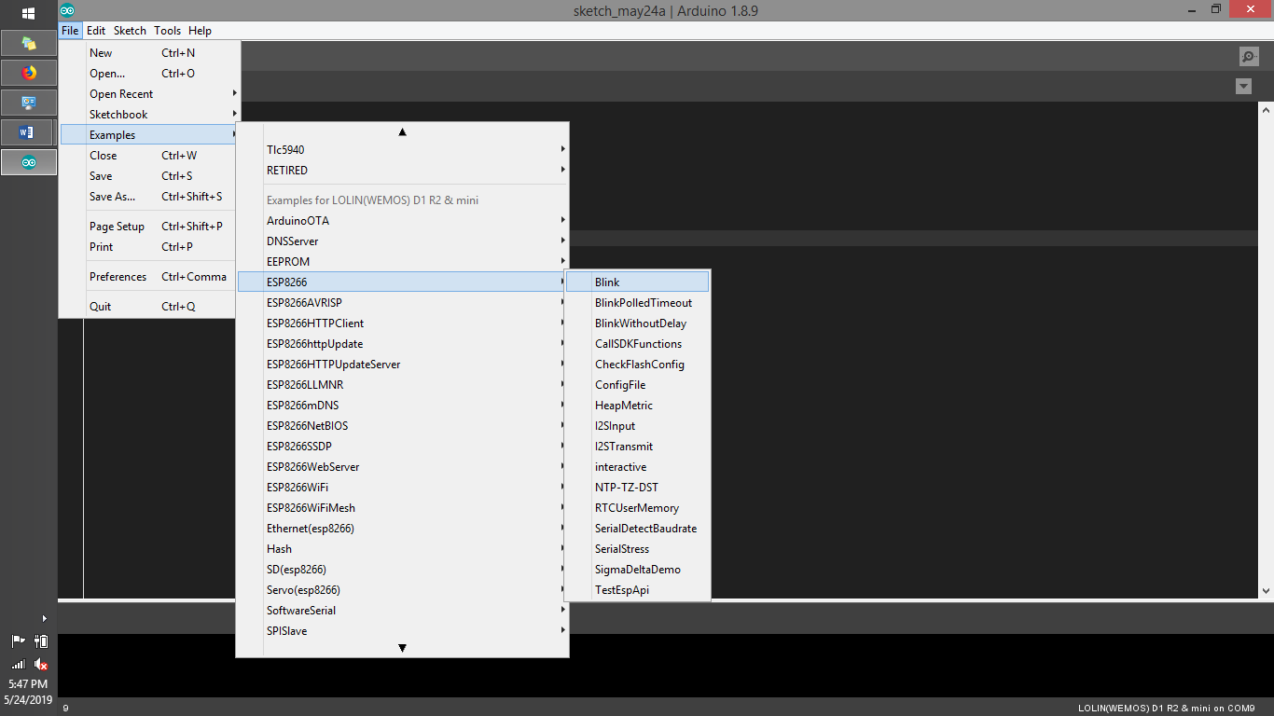

* A new window will open.

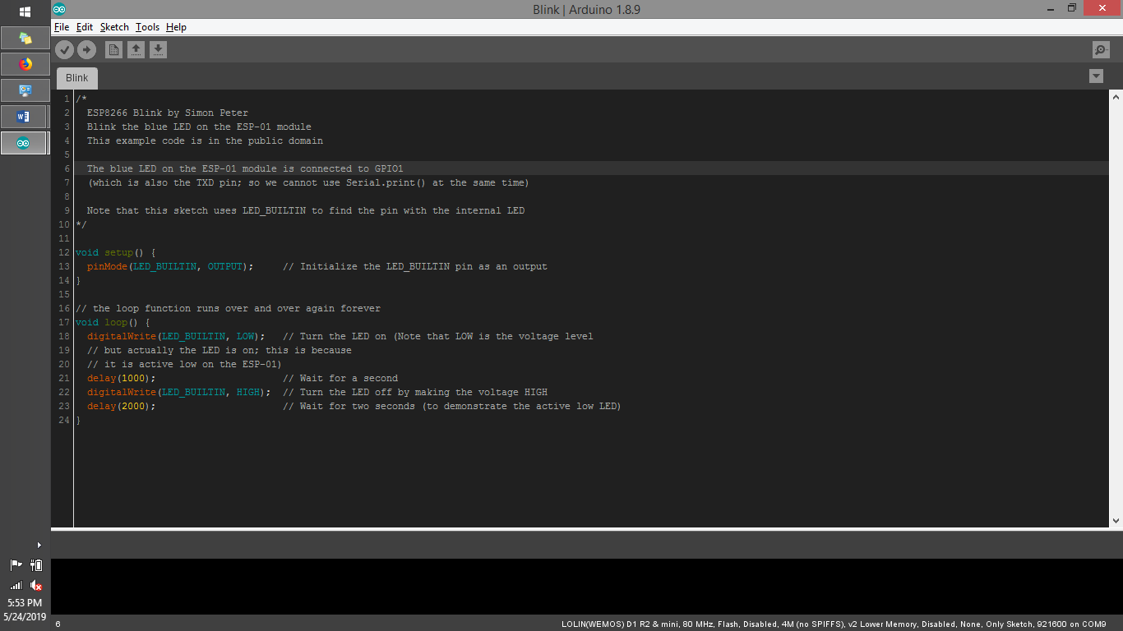

* Now you need to install the driver you need so you can upload code from Arduino IDE to WeMos D1 R1.
* Download CH340X Driver

<https://wiki.wemos.cc/downloads>

* Just download, extract and install the driver as shown.

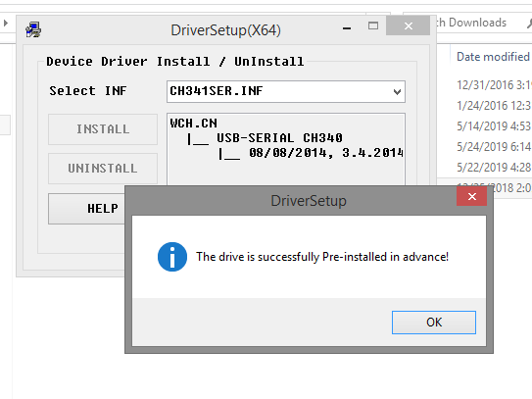

* Now go back to Arduino IDE and go to Tools->Ports and select the port of the WeMos D1 mini.
* It should have a list named as COMX where X is any number.
* After selecting that, upload the code the board.
* A “Done Uploading” message should be shown on the lower left side of the Arduino IDE.
* The built-in LED should be blinking in your board.
* Once you have accomplished that part, you are now ready to build the circuit.
* We only have a generic photodiode and no the required one which is mentioned in your RRL so we’ll just experiment with the generic one.
* Built the circuit below on the breadboard.
* 5V is from the WeMos D1 mini.
* OP491 is replaced by LM358, see image next page, they have the same pinout (the one with the triangle symbol.)





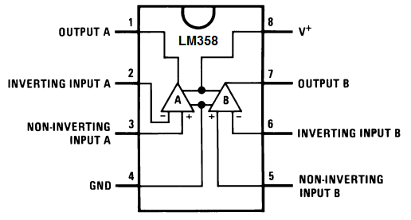

* V1 is 5V from the WeMos D1 mini.
* V2 is 5V from the booster, both should have a common ground.
* I’ll send the code next time.
* You just need to see if the voltage reading varies as you move the position of the NIR and photodiode.